**Creating Kubernetes Dashboard with Node_Port**

**Solution Link:** <https://computingforgeeks.com/how-to-install-kubernetes-dashboard-with-nodeport/>

**Step 1: Configure kubectl**

We’ll use the kubectl kubernetes management tool to deploy dashboard to the Kubernetes cluster. You can configure kubectl

**Step 2: Deploy Kubernetes Dashboard**

The default Dashboard deployment contains a minimal set of RBAC privileges needed to run. You can deploy Kubernetes dashboard with the command below.

**kubectl apply -f** <https://raw.githubusercontent.com/kubernetes/dashboard/master/aio/deploy/recommended.yaml>

This will use the default values for the deployment. If you want to make some modifications to the file, you’ll have to download it to your local machine.

**Wget** <https://raw.githubusercontent.com/kubernetes/dashboard/master/aio/deploy/recommended.yaml>

*Make the copy of yml file*

**mv recommended.yaml kubernetes-dashboard-deployment.yml**

*Modify the file to fit your deployment needs.*

**vim kubernetes-dashboard-deployment.yml**

*I’ll modify the Kubernetes dashboard service to be of NodePort type.*

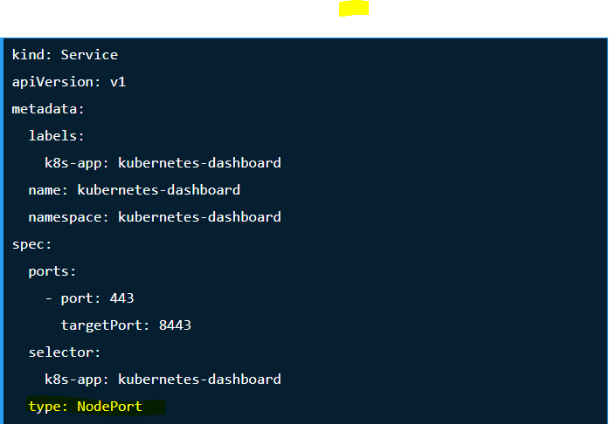

*NodePort exposes the Service on each Node’s IP at a static port (the NodePort). A ClusterIP Service, to which the NodePort Service routes, is automatically created.*

**kubectl apply -f kubernetes-dashboard-deployment.yml**

*Run the following command to verify the Dashboard deployment, Pods and service running or not*

**kubectl get deployments -n kubernetes-dashboard**

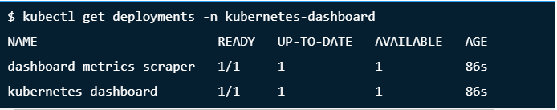

**kubectl get pods -n kubernetes-dashboard**

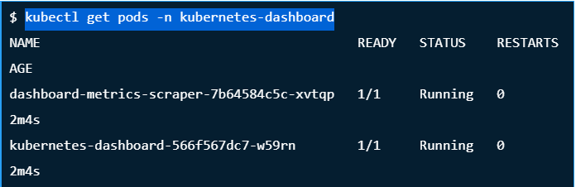

**kubectl get service -n kubernetes-dashboard**

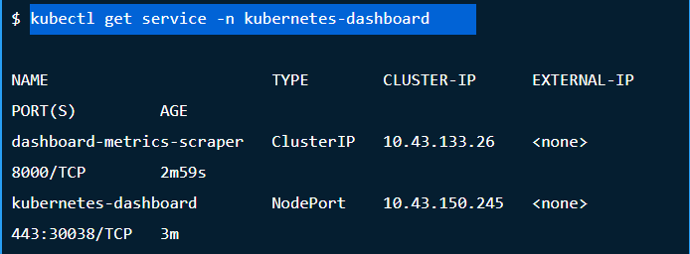

**Step 3: Accessing Kubernetes Dashboard**

My Service deployment was assigned a port **30038**/**TCP**. Let’s confirm if access to the dashboard is working.

**Solution Link:** <https://www.replex.io/blog/how-to-install-access-and-add-heapster-metrics-to-the-kubernetes-dashboard>

**Kubernetes Dashboard Authentication**

There are two options to authenticate our Kubernetes dashboard account; using either the token or the kubeconfig method. For the purposes of this tutorial, we will use the token authentication method.

**Create the dashboard service account**

**kubectl create serviceaccount dashboard-admin-sa**

This will create a service account named dashboard-admin-sa in the default namespace

Next bind the dashboard-admin-service-account service account to the cluster-admin role

**kubectl create clusterrolebinding dashboard-admin-sa   
--clusterrole=cluster-admin --serviceaccount=default:dashboard-admin-sa**

When we created the dashboard-admin-sa service account Kubernetes also created a secret for it.

**kubectl get secrets**

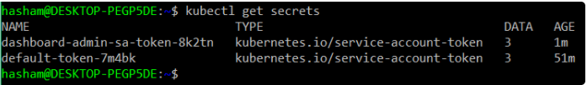

***Use kubectl describe to get the access token:***

**kubectl describe secret dashboard-admin-sa-token-kw7vn**

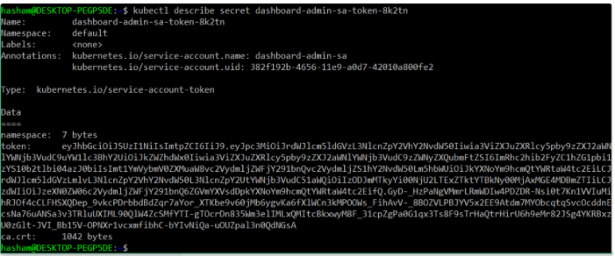

Copy the token and enter it into the token field on the Kubernetes dashboard login page.